

Two tables needed:

1. Market price table, copy from P/E folder after completion.
2. CASH EPS: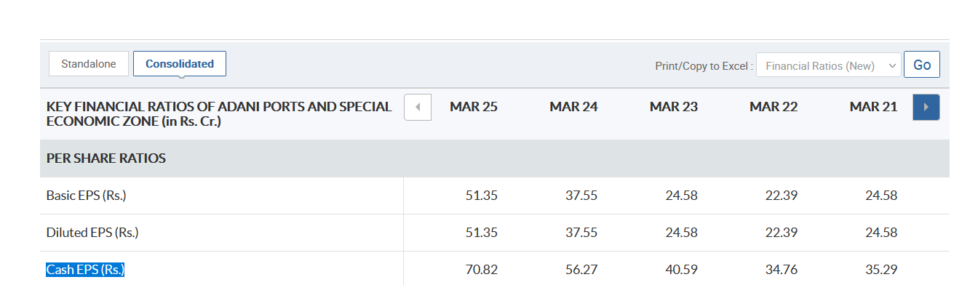process same as before, just make sure **consolidated is selected for each company. Then just divide.**